Self-isolating children:
Maths by week on White Rose online
 | WB 14.12.20
Year 3 | White Rose week  Mon: Week 12 lesson 1- 4 x table  Tues: Week 12 lesson 2- Multiply by 8  Weds Week 12 lesson 3- Divide by 8  Thurs: Week 12 lesson 4- 8 x table  Fri: Contingency for catch-up
 | Topic
Year 4 | White Rose week  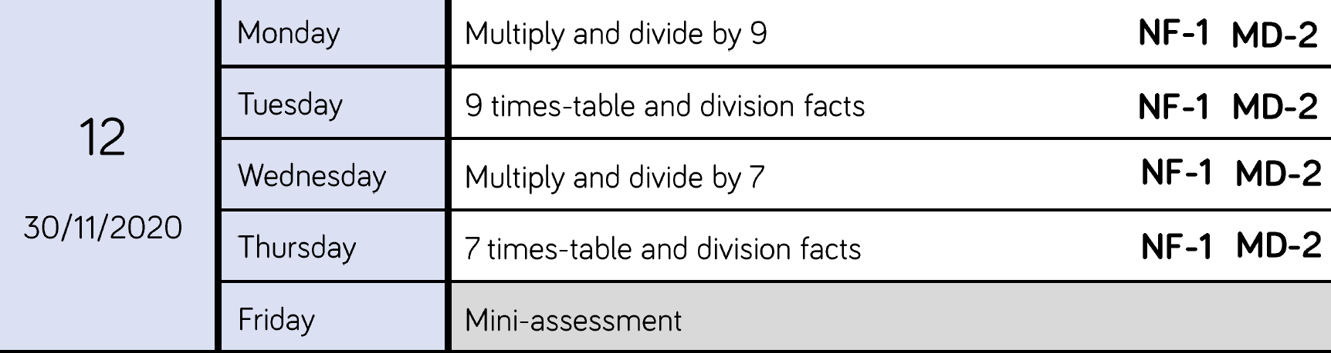
Topic
Multiplication and division
Year 5 | White Rose week  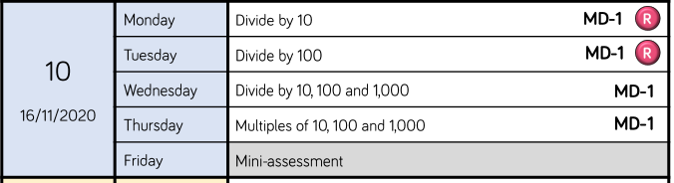
Topic
x10, 100, 1000
/ 10, 100, 1000
Multiples of 10, 100, 1000
Possible assessment
Year 6 | White Rose week  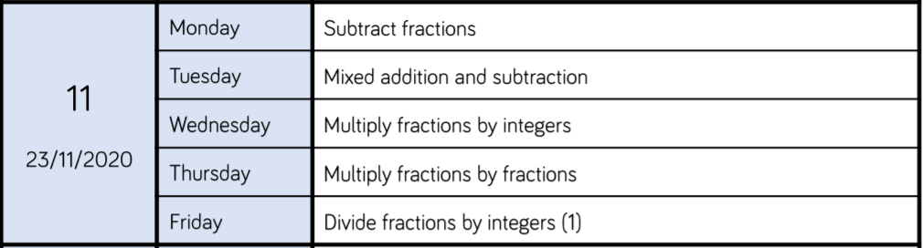
Topic
Fractions

