Outdoor Learning Challenges – Try to complete at least eight of the challenges below
Spotting Game  Make a list of things to find out on a walk or in the garden (e.g. a tree, a bird, a petal, something ‘yellow’, something that starts with every letter of the alphabet (A–Z), a snail, a leaf etc.).  You could take photos and create your own spotters’ guide! | I Spy  Choose an object and use the phrase  I spy with my little eye, something beginning with the letter …  See how many guesses it takes for someone to find out what you’ve chosen! | Twenty Questions  Play with someone else! Think of something and then the other person has to ask up to 20 questions to guess what it is.  You could choose from different categories like an animal, a vegetable or fruit or something that moves! | Den Building  Create a den so that you can do some reading outside. Think about keeping warm and dry!  Once the den is made, sit back, relax and read!  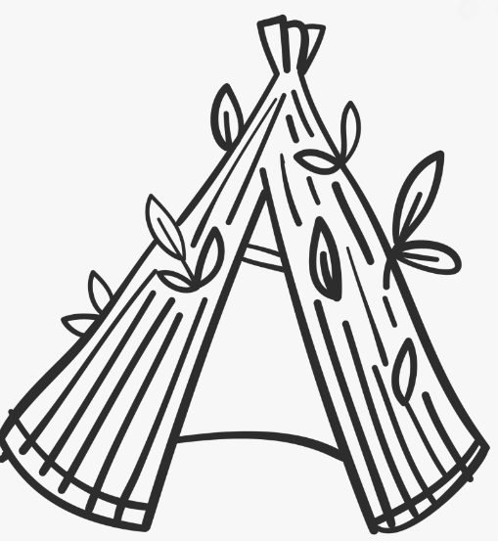 | Treasure Hunt  Collect some items from outside (e.g. a shell, a flower or a pebble).  Create an exhibition by writing a label and a caption for each item.  (e.g. This is a … It is …)  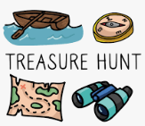
Cloud Busting  Lie on your back or look up at the sky. If you can see a cloud, what do you think it is?  Could it be an animal, a person, a vehicle? Describe what it looks like. | Poetree  Use your senses to explore the trunk, branches, buds and/or leaves of a tree.  Create a poem or short piece of descriptive writing about it.  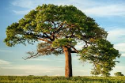 | Garden Potions  Put some water in a container or small bucket. Create your own fantastic potion, adding any natural objects you can find. Write a list of what you used to make your potion! | Window Watch  How many things can you see out of the window that start with …  B  S  D  T  C  G | Small World  Collect a range of natural materials (e.g. twigs, moss, fir cones, acorns) and make a tiny world for toys, action figures or animals.  What about a …  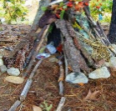  - stick fort  - farm or zoo  - fairy house

