MCj04247780000[1]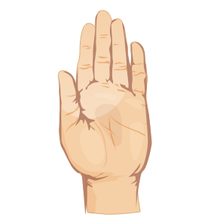MCj04377970000[1]

Look Say Cover Write Check

|  |  |
| --- | --- |
| Given: 11th January  Test: 18th January | 1. certain 2. describe 3. favourite 4. minute 5. important 6. probably 7. surprise 8. special 9. quarter 10. fantastic |
| Given: 18th January  Test: 25th January | 1. baguette 2. disguise 3. guard 4. guess 5. guide 6. guilt 7. guitar 8. guest 9. guarantee 10. guise |
| Given: 25th January  Test: 1st February | 1. capture 2. creature 3. feature 4. lecture 5. mixture 6. nature 7. picture 8. puncture 9. future 10. culture |
| Given: 1st February  Test: 8th February | 1. kittens’ 2. women’s 3. men’s 4. brothers’ 5. children’s 6. babies’ 7. mice’s 8. teachers’ 9. lions’ 10. boys’ |
| HALF TERM | |
| Given: 1st March  Test: 8th March | 1. international 2. intercept 3. antiseptic 4. antihistamine 5. interpret 6. internet 7. intervene 8. antibiotic 9. anticlimax 10. antidote |
| Given: 8th March  Test: 15th March | 1. climbing 2. gasped 3. helper 4. warmest 5. flying 6. watched 7. colder 8. longest 9. buzzing 10. smoothest |
| Given 15th March  Test: 22nd March | 1. possession 2. therefore 3. medicine 4. separate 5. continue 6. disappear 7. peculiar 8. though 9. experiment 10. February |
| Given: 22nd March  Test: 29th March | 1. possession 2. magician 3. direction 4. extension 5. explosion 6. permission 7. electrician 8. fiction 9. occasion 10. collision |
| Given: 29th March  Test: 5th April | 1. pair 2. pear 3. wail 4. whale 5. grate 6. great 7. ate 8. eight 9. sail 10. sale |
| END OF TERM | |