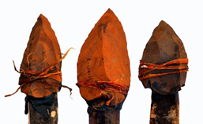

**French:**

* Learn numbers 1–10.
* Use simple greetings.
* Learn some simple commands.

**History/Geography:**

* Stone Age to Iron Age
* Comparing housing and life style – Settlements
* Farming over time
* Stonehenge – Map work
* Information leaflets – time and place

**PE:**

* Premier Sport (Swallows)
* Ball skills and gymnastics (Doves)

The Bellbird Primary School

**‘Soaring to Success’**

Year 3 Autumn Term

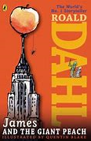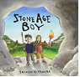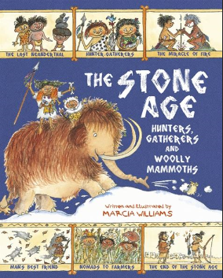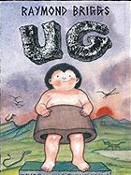

**Computing:**

* Typing – children learning basic typing skills
* Online safety
* Use email system

**Art/DT:**

* Design own Neolithic pottery
* Draw and paint own cave paintings
* Cooking and Baking
* Healthy diets

**RE: Judaism**

* Who and Where? Special places, festivals, symbols and meanings.
* Visit to a synagogue in Cambridge - tbc

**PSHCE:**

* Understand differences between rights, wants and needs
* My emotions

**Science:**

* Investigating light and shadow.
* Investigating rocks and soils.

**Mathematics:**

* Number – Place Value
* Number – Addition and Subtraction

(including money)

* Number – Multiplication and Subtraction

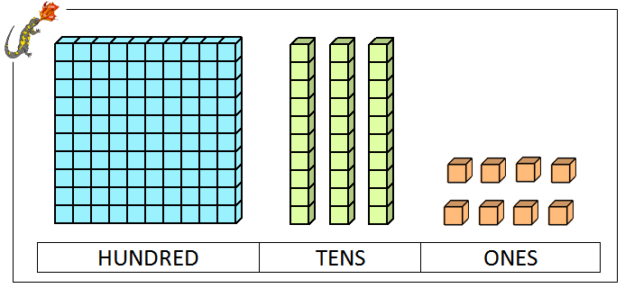

**Music:**

* In Yr 3 children learn to play the recorder – children will be provided with recorders
* Music Express and Singing

**Literacy:** **James and the Giant Peach by Roald Dahl**

* Dialogue and speech punctuation – inverted commas
* Vocabulary linked to characters
* Descritive langauge to expresss feelings and emotions
* Comprehension, reasoning and analysis of text

**Stone Age Boy by Satoshi Kitamura**

* Correct use of fronted adverbials
* Constructing verbs in the past tense
* Language of comparison and contrast
* Correct use of prepositions and prepositional phrases

**‘**

**Topic Name**

**Yabadabadoo!**

[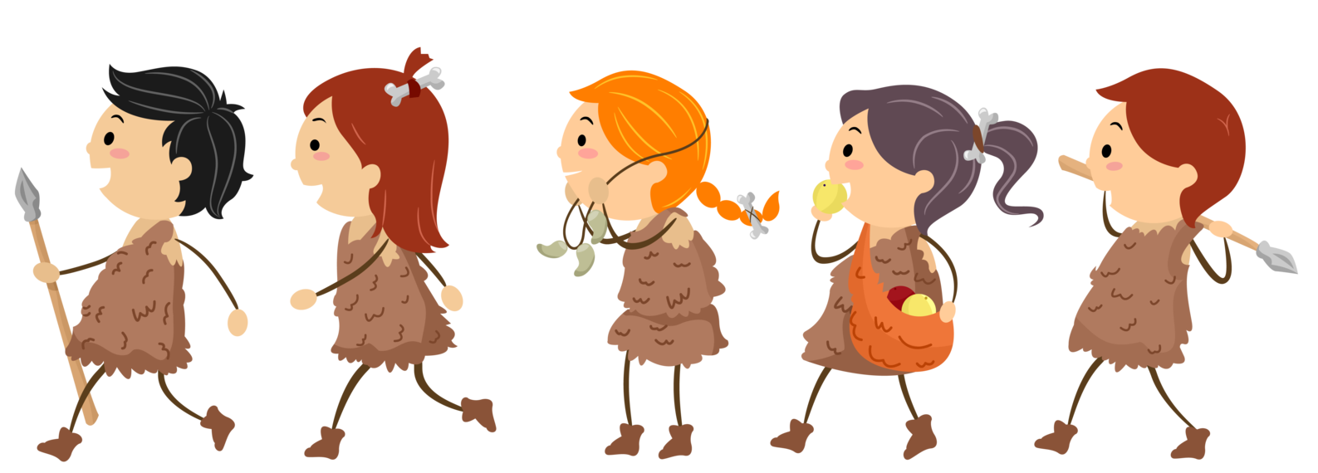](https://www.google.co.uk/url?sa=i&rct=j&q=&esrc=s&source=images&cd=&cad=rja&uact=8&ved=2ahUKEwjpnZjvlIjdAhVNQhoKHQakD1UQjRx6BAgBEAU&url=https://steemit.com/archaeology/@zest/the-early-stone-age-chronology-and-adaptation&psig=AOvVaw3VeTFLC13YGXy3ryfV7tTy&ust=1535284922165806)