We would like you to complete at least 3 of the activities on the following pages.  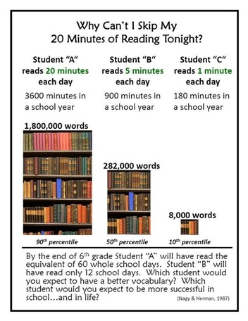  Please also continue to read with your child for at least 15 minutes each day. | Have fun!  We’re looking forward to seeing your creations before Friday 14th December. | Year 1 Autumn homework menu  - “Past and Present” topic
This term we are looking at life in the past, particularly homes and toys.  We would like you to complete at least 3 of the activities on the following pages. These can be brought into school any time before Friday 14th December and will be shared each week on Fridays. | - Talk to the oldest person you know (maybe an elderly neighbour, family friend or a grandparent). Ask them about what they used to do and play with when they were younger.  - Find some black and white photos.  - Find information about transport in the past.  - Search the internet for toys in the past. You could draw a picture, make a poster, write about it or make a presentation.  - Can you make your own toy from the past? | - Find out what toys were made of in the past. Did they have plastic? Did toys se batteries?  - Take photographs or draw a picture and write about your favourite toys.  - Find out about how people used to wash their clothes and cook in the past.  - Discover how homes were different in the past.  - How were schools different in the past?  - How did people listen to music in the past?

