

**PE:**

Running, jumping, throwing and catching, as well as developing balance, agility and co-ordination.

Performing dances using simple movement patterns.

**RE:**

What makes church a special place for Christian people? Why is Christmas important to Christians?

**History:**

Our History topic this term will be “Past and Present” focusing on the question what was everyday life like in the past.

**Wagtails + Sparrows**

Reading folder in book bag every day

PE Kit to leave in school:

Wagtails – Wednesday and Friday

Sparrows – Tuesday and Friday

Water bottle

Apron or old t-shirt for creative activities

The Bellbird Primary School

**‘Soaring to Success’**

Year 1 Autumn Term

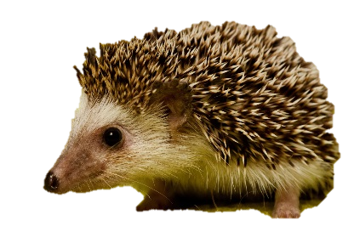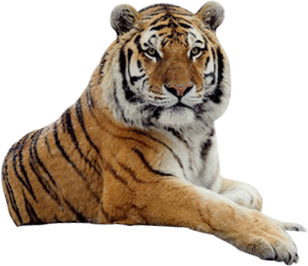

**Mathematics:**

We will focus on numbers to 20 for this term to consolidate children’s understanding.

We will be looking at Place Value, Addition and Subtraction and Shape.

We would appreciate if you could work on these things at home.

**Science:**

In Science we will be looking at types of animals and parts of animals including humans.

We will be thinking about health and growth.

**Music:**

Use voices expressively and creatively by singing songs and speaking chants and rhymes.

Listen with concentration to a range of live and recorded music and experiment with different instruments.

**English:**

We start this term by learning about Quentin Blake. We will then look at non-fiction books focusing on tigers before moving on to *The Tiger Who Came to Tea* (to include work on instructions and invitations).

Later this term, we will be learning about non-fiction books focusing on hedgehogs and will link our work to the seasons.

We will also be looking at poetry and *The Jolly Postman*.

Throughout the term children will be applying their phonic understanding which will be developed through our daily phonics sessions.

**PSHE**:

We will be looking at responsibilities (thinking about people who look after us and the responsibility we have to them).

We will also be learning about understanding and developing rules and democracy and decision making in the classroom and wider school community.

**‘Topic: Past and Present**

**Children will spend this term looking at life in the past particularly homes and toys. This will link to work in Art and DT.**

**Homework**

**Children will have a Homework Menu with different activities related to our topic. We expect children to do at least three of these activities by the end of the Autumn term.**

**Art/DT:**

We will take inspiration from author and illustrator Quentin Blake for our work on watercolour painting and mixed media.

We will be making sweet treats alongside instruction writing.

Peg dolls.