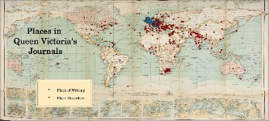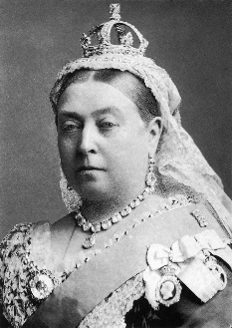 

**French:** We will be learning key French vocabulary such as things you would find in a classroom and comparing these to things you might find in a Victorian classroom. Un tableau blanc ou un tableau noir?

**History and Geography:**

We will learn about what life would have been like in Cambridge in Victorian times. We will also learn about Victorian childhoods and the jobs children may have undertaken, as well as looking at how Victorian inventions and development have affected the landscape. We will focus on UK geography, including physical features, human activities and work in the UK in the modern day and the Victorian period.

**PE:**

All of Woodpeckers’ P.E. this year will be taught by coaches from Premier Sport. This will take place on a Thursday afternoon and the children will access both indoor and outdoor sessions.

The Bellbird Primary School

**‘Soaring to Success’**

Year 4/5 Autumn Term

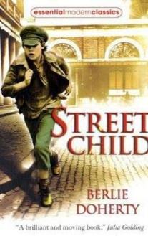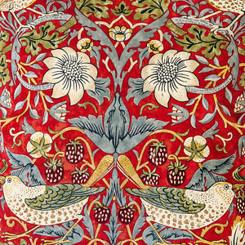

**Computing:**

We will use Scratch to learn more about coding as well as learning to use Microsoft Office applications.

**Art/DT:** We will be designing and making our own Victorian era toy as well as learning about Victorian artists such as William Morris.

**Science:**Earth and space: we will describe the movement of Earth, and other planets, relative to the Sun in our Solar System. We will use the idea of Earth’s rotation to explain day and night and the apparent movement of the Sun across the sky.  
Forces: children will learn about forces including gravity, air resistance, water resistance and friction. They will also observe and explain how gravity causes an unsupported object to fall towards the Earth.

**Music:** All of the children will be given a recorder and we will be learning how to perform as a group.

**RE:** What influences the Jewish people? We will learn about Jewish beliefs, practices and festivals.  
Christianity and Judaism. We will examine the meaning of the term ‘religion’ from a Christian, Jewish and secular perspective. The importance of having something to believe in leading to signs of outward commitment will be explored. The focus will be upon key rites of passage marking adulthood into a faith and a commitment to a religion

**PSCHE:**

Beginning and belonging

Family and Friends

Anti-bullying

**Mathematics:**

This term sees a strong focus on number work. We begin with place value, looking at different ways to represent numbers, counting in multiples, comparing and ordering, rounding and developing our understanding of negative numbers. These topics will be differentiated to ensure your child accesses the appropriate content for their year group. Following this, we move on to developing strategies for the four operations and finish off the topic with a look at measure, particularly length and perimeter.

**English:**

*Reading:* We will begin by reading “The Witches” by Roald Dahl. This will be followed by “Street Child” by Berlie Doherty and we will make links between this text and “Oliver Twist”. Later in the term, we will also look at the picture book “Farther” to coincide with our work on remembrance and “Tom’s Midnight Garden” by Philippa Pearce.

*Writing:* Our writing will involve a mixture of narrative writing including a time travelling element linked to “Tom’s Midnight Garden”. We will also be doing some writing in role based on “Street Child” and instructions, character descriptions and play script writing linked to “The Witches”

*Speaking and Listening:* The children will participate in a class debate

*Grammar:* Grammar and punctuation will be taught through a series of short, interactive sessions and it is expected that the children will then apply these skills to their independent writing.

*Spelling:* This will focus on the relevant spelling patterns for your child’s year group as well as learning the statutory word lists for Key Stage 2.

*Handwriting:* The children will continue to develop a fluent, joined writing style.

**‘What the Dickens?**

The children will spend this term learning about the reign of Queen Victoria and key moments in the Victorian Era. This will link to work in Art, DT, History, Geography and English.