 

Music

We will explore Caribbean music and instruments and learn some Caribbean songs.

**PE:**

PE for both classes will take place on a Wednesday afternoon with Premier sport coaches.

Please ensure your child has suitable school PE kit and footwear for outdoor PE.

**Topic:**

Our topic this term takes us to the Caribbean! We will be locating and naming continents and oceans before we explore and compare the island of Jamaica with the UK. The children will research information about Jamaica using maps, books and the internet. We have attached the key knowledge and vocabulary we will be learning.

**:**

The Bellbird Primary School

**‘Soaring to Success’**

Year 2 Autumn Term 1

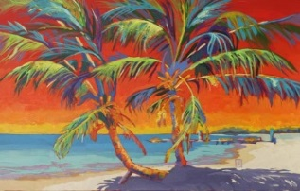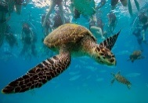

**‘Topic**

Over the Sea and Far Away

**Key Dates:**

Roald Dahl day

The children can come dressed up as their favourite Roald Dahl character on Wednesday the 12th September.

Our Roald Dahl text is ‘The Twits’. The children are really enjoying exploring the characters of Mr. and Mrs. Twit and are suitably horrified by their nasty tricks!

**Key Dates:**

**English: Reading**

The children will be encouraged to change their home reading books on Monday, Wednesday and Friday when their reading record books will also be checked.

**Phonics, Spelling and Handwriting**

The children follow the national Letters and Sounds phonic programme and our main focus this term will be revising Phase 5 and teaching Phase 6 (prefixes and suffixes). Spellings will link to the phonic phase your child is accessing this term. Spellings will be given out on a Friday and the test will take place on the following Friday.

The weekly spelling lists will be coming home in the Letter-join font and individual letter formations will be placed on the school’s website.

**RE:**

In RE the children will make preparations for Harvest Festival through our Bellbird Wheat project. We will also explore Sikhism.

**Art and DT:**

Art will usually be linked to topic work.

We will study Caribbean landscapes and develop observational drawing skills using tropical fruits.

We will explore Caribbean food and try out recipes!

Children need to bring in an old shirt or apron (named) for art and DT.

**PSHE:**

Our PSHE work focuses on rights, rules and responsibilities. The children will have the opportunity to identify their own responsibilities both in and out of school.

**Science:**

Our Caribbean topic links with our science theme on health and growth (‘Humans and other Animals’).

We will learn how animals, including humans, have offspring which grow into adults. We will find out about and describe the basic needs of animals.

We will learn about the importance for humans of exercise, eating the right amounts of different types of food, and hygiene.

**Mathematics:**

Our maths work this term will focus on place value, counting, comparing and representing numbers to 100 and reading and writing numbers in numerals and words. The children will be counting on and back in 1’s, 2’s, 5’s, 10’s and 3s.

We will then move onto addition and subtraction of two-digit numbers.

All year 2 children will be given Mathletics accounts to access in school and for home learning. Mathletics is an online learning platform that allows parents to see the methods we use to teach calculation skills and provides the children with opportunities to practise skills at home.