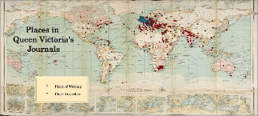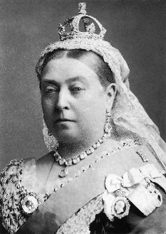 

**French:** We will be learning key French vocabulary such as things you would find in a classroom and comparing these too things you might find in a Victorian classroom. Un tableau blanc ou un tableau noir?

**History and Geography:**

We will learn about what life would have been like in Cambridge in Victorian times. We will also learn about Victorian childhoods and the jobs children may have undertaken, as well as looking at how Victorian inventions and development have affected the landscape. We will focus on UK geography, including physical features, human activities and work in the UK in the modern day and the Victorian period.

**PE:**

Team sports were extremely popular in Victorian times as they promoted rules, fair play and discipline. Football and rugby were both big sports in the Victorian times.

Theatre flourished in the Victorian era and this term we will be doing a scheme of work based on the musical ‘Cats’.

The Bellbird Primary School

**‘Soaring to Success’**

Year 5 Autumn Term

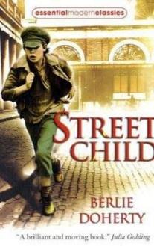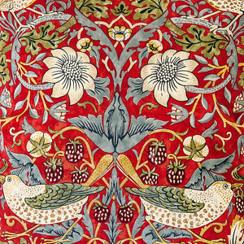

**RE:**

What is faith?

Christianity and Judaism

**PSCHE:**

Beginning and belonging

Family and Friends

Anti-bullying

**Music:** All of the children will be given a recorder and we will be learning how to perform as a group.

**Science:**

Earth and space

Forces and magnets

**Mathematics:**

This term sees a strong focus on number work. We begin with place value, looking at different ways to represent numbers, counting in multiples, comparing and ordering, rounding and developing our understanding of negative numbers. These topics will be differentiated to ensure your child accesses the appropriate content for their year group. Following this, we move on to developing strategies for the four operations and finish off the topic with a look at measure, particularly length and perimeter.

**English:**

*Reading:* We will begin by reading “The Witches” by Roald Dahl. This will be followed by “Street Child” by Berlie Doherty and we will make links between this text and “Oliver Twist”. Later in the term, we will also look at the picture book “Farther” to coincide with our work on remembrance and “Tom’s Midnight Garden” by Philippa Pearce.

*Writing:* Our writing will involve a mixture of narrative writing including a time travelling element linked to “Tom’s Midnight Garden”. We will also be doing some writing in role based on “Street Child” and instructions, character descriptions and play script writing linked to “The Witches”

*Speaking and Listening:* The children will participate in a class debate

*Grammar:* Grammar and punctuation will be taught through a series of short, interactive sessions and it is expected that the children will then apply these skills to their independent writing.

*Spelling:* This will focus on the relevant spelling patterns for your child’s year group as well as learning the statutory word lists for Key Stage 2.

*Handwriting:* The children will continue to develop a fluent, joined writing style.

**‘What the Dickens?**

The children will spend this term learning about the reign of Queen Victoria and key moments in the Victorian Era. This will link to work in Art, DT, History, Geography and English.

**Key Dates:**

**Art/DT:** We will be designing and making our own Victorian era toy as well as learning about Victorian artists such as William Morris.

**Computing:**

Children will be using ICT for research when looking into key facts about Victorian life.