Key facts we will be learning | Key words we will be learning
- There are 7 continents on Earth: Asia, Africa, Europe, North America, South America, Oceania, Antarctica.  - There are 5 oceans on Earth: Arctic, Atlantic, Indian, Pacific, Antarctic.  - The Caribbean Islands are located on the continent of North America. 5 Caribbean countries are: Jamaica, Dominican Republic, Haiti, Barbados, Cuba.  - The United Kingdom has a population of 65 million. Jamaica has a population of 3 million.  - 70% of Earth is made up of water. 30% is made up of land. | - Continent: a major area of land.  - Country: a large area of land where people are ruled by the same government.  - Island: a small area of land surrounded by water on all sides.  - Ocean: a huge area of salt water.  - Atlas: a book of maps.  - Locate: to find the position of something.  - Compass: a tool for showing direction: north, south, east, west.
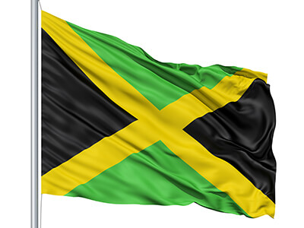
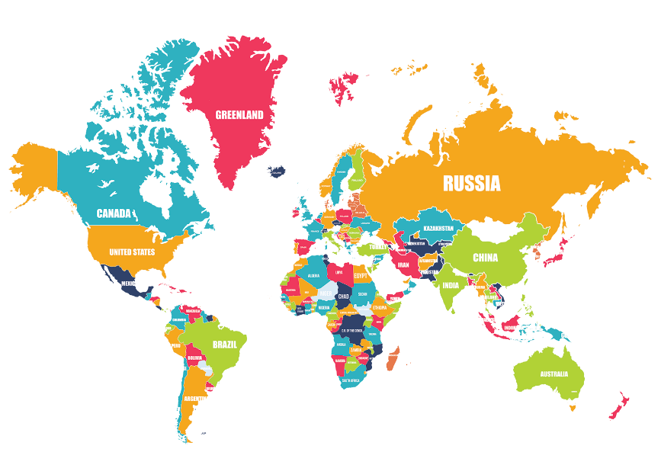
Topic: Over the sea and far away Year 2 Autumn term

